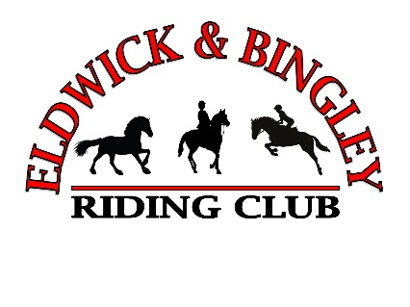
ELDWICK & BINGLEY RIDING CLUB 2024
MEMBERSHIP FORM
Please ensure you have submitted the appropriate payment via www.horsemonkey.co.uk.
PLEASE STATE THE NAME AND EMAIL PAYMENT WAS SUBMITTED UNDER
Name:
Email:

PLEASE STATE THE MEMBERS NAME
Name:

AGE IF UNDER 16 ON THE 1ST JANUARY
Age:

EMAIL ADDRESS
Email:

PHONE NUMBER
No:

EMERGENCY CONTACT NUMBER AND NAME
No:
Name:
PONY / HORSE 1
Name:
Breed / Type: Age:

PONY / HORSE 2
Name:
Breed / Type: Age:

PLEASE TICK TO OPT IN TO EVENT COMMUNICATIONS VIA EMAIL
Please allow up to 7 days for us to process your membership.
Please email this form or the information to: eldwickridingclub.@gmail.com
Thank you for joining EBRC for 2024 see our website and Facebook page for events and news

